|  |  |
| --- | --- |
| **PROJECT NAME:** | **INDUSTRY-SPECIFIC INTELLIGENT FIRE MANAGEMENT SYSYTEM** |
| **TEAM ID:** | **PNT2022TMID37462** |

**CREATE JIRA SOFTWER:**

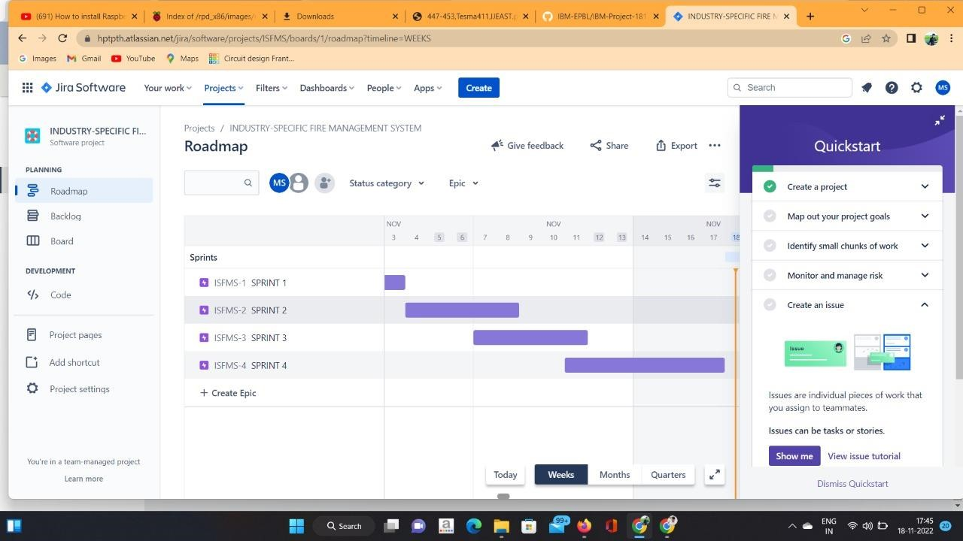

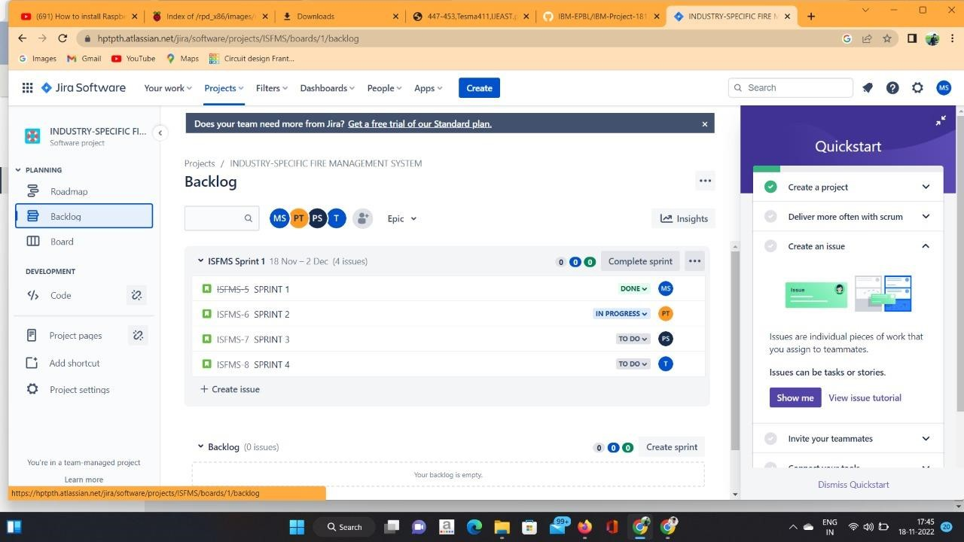

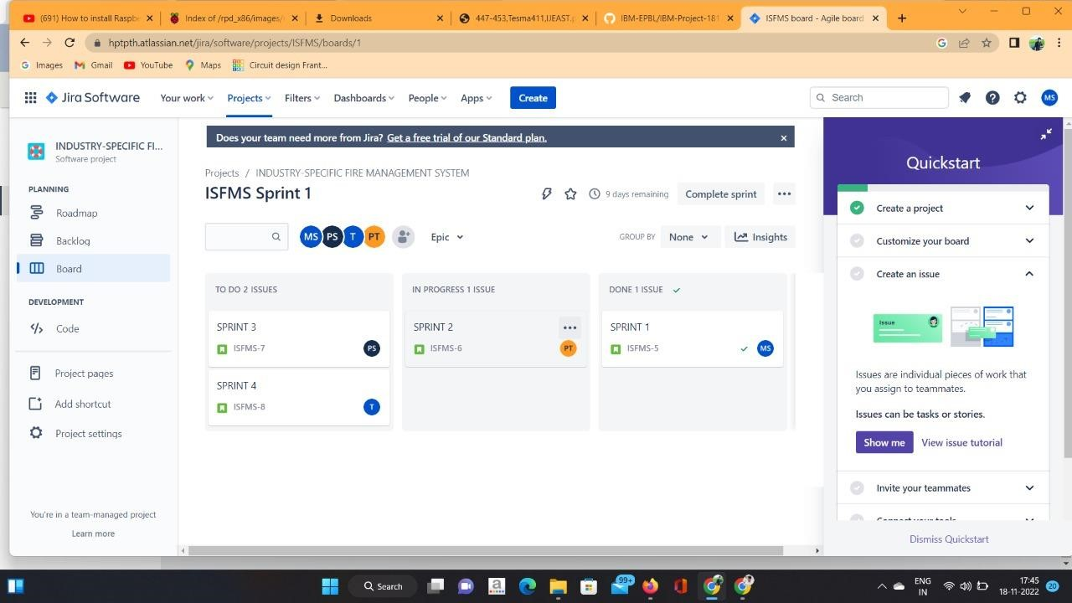

**RESULT:**

**Thus the JIRA SOFTWER was successfully completed.**